About our Facilitators:
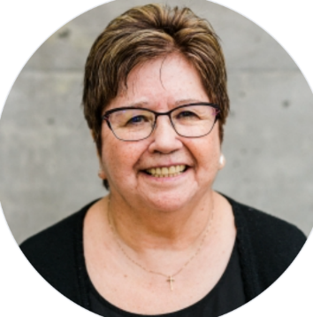
Patti is Sto:lo and is living on the traditional ancestral unceded territory of Cheam First Nation where she enjoys her children and grandchildren. She and her late husband Gary are the founding pastors of a thriving First Nations Church in Chilliwack. She is an ordained minister with the Pentecostal Assemblies of Canada.
Patti earned her B.A. in Pastoral Theology at Summit Pacific and her M.A. in Leadership at Trinity Western University. She is the chair of Indigenous Partnership Council and director of Institute of Indigenous Issues and Perspectives. In her role of TWU Siya:m, Patti teaches Indigenous perspectives across disciplines; coaches and mentors Indigenous students; builds relationships with Aboriginal communities; and provides opportunities for TWU community to understand Indigenous perspectives in education, spirituality, community, history and reconciliation.
Patti's passion is to build bridges with Aboriginal community through education: through professional development workshops for educators, Aboriginal Awareness workshops for churches or facilitating events where greater understanding of Indigenous ways of knowing and being are developed and the journey of reconciliation can flourish.
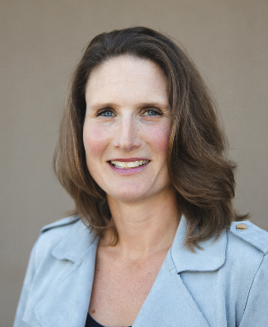

Rachel Vroege is privileged to live with her husband Russ and four children on the Stó:lō unceded traditional territory of the Pilalt, Semá:th and Ts’elxwéyeqw tribes. She is the Western Canada Regional Developer for Diaconal Ministries Canada and works to equip CRC deacon teams in justice, benevolence, community and stewardship ministries.
For the past 7 years, Rachel has led the Kairos Blanket Exercise for church groups and in the Chilliwack public school system for Grades 4-6 in partnership with Indigenous teachers and is committed to supporting reconciliation in Canada through these learning opportunities.

