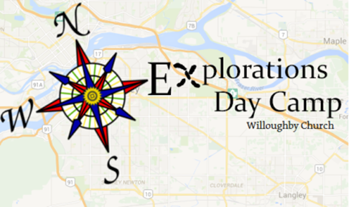

Explorations Day Camp will include crafts, games, and out-trips to nearby attractions. Registration is $75/ child. A 50% discount is available for the third sibling enrolled. Bring completed forms to the church office with payment. If you have any questions, do not hesitate to contact Laura at 604-530-5959, or [laura@willoughbychurch.com](mailto:laura@willoughbychurch.com)

*Your child is required to bring a bagged lunch on each day of camp. Snacks will be provided.*

Child’s Information

Child’s Name: Age: Birthdate:

T-Shirt Size Youth: S M L

How I heard about camp:

Physical/ Medical Information

Medications/ allergies/ restrictions:

Parent/ Guardian Information

Name:

Home Address:

City: Postal Code: Phone Number:

Email Address:

Emergency Contact Information

Name:

Relationship: Phone Number:

*The information contained in this form is used exclusively by Willoughby Church to register your child in the Explorations Day Camp program and to assist the church to respond immediately to an emergency.*

**Explorations   
Day Camp   
Registration Form**

August 8-12   
8:30am- 4:30pm